AI Assisted Coding
Lab_Assignment_2.3
2303A51395
Batch-06
PROMPT:
Task 1: Word Frequency from Text File
- Scenario:
You are analyzing log files for keyword frequency.
- Task:
Use Gemini to generate Python code that reads a text file and counts word frequency, then explains the code.
- Expected Output:
- Working code
- Explanation
- Screenshot
Code:
# First, let's create a dummy text file for demonstration purposes.
file_content = """This is a sample text file.
This file will be used to count word frequencies. Sample text, sample words, sample frequency.""" with open('sample_log.txt', 'w') as f:
f.write(file_content)
print("Created 'sample_log.txt' with sample content.")
import re
from collections import Counter def count_word_frequency(filepath): """
Reads a text file and counts the frequency of each word.
Args: filepath (str): The path to the text
file.
Returns:
collections.Counter: A Counter object where keys are words and values are
their frequencies. """ words = [] with open(filepath, 'r') as f:
for line in f:
# Convert to lowercase and remove punctuation, then split into words
# re.findall('\b\\w+\\b', ...) finds all word characters words.extend(re.findall(r'\b\w+\b', line.lower()))
return Counter(words)
# Specify the path to the text file file_path = 'sample_log.txt' # Count word frequencies word_counts = count_word_frequency(file_pat
h)
# Display the top 10 most common words print("\nWord Frequencies (Top 10):") for word, count in word_counts.most_common(10): print(f"'{word}': {count}")
OUTPUT:
Word Frequencies (Top 10):
'sample': 4
'this': 2
'text': 2
'file': 2
'is': 1
'a': 1
'will': 1
'be': 1
'used': 1
'to': 1
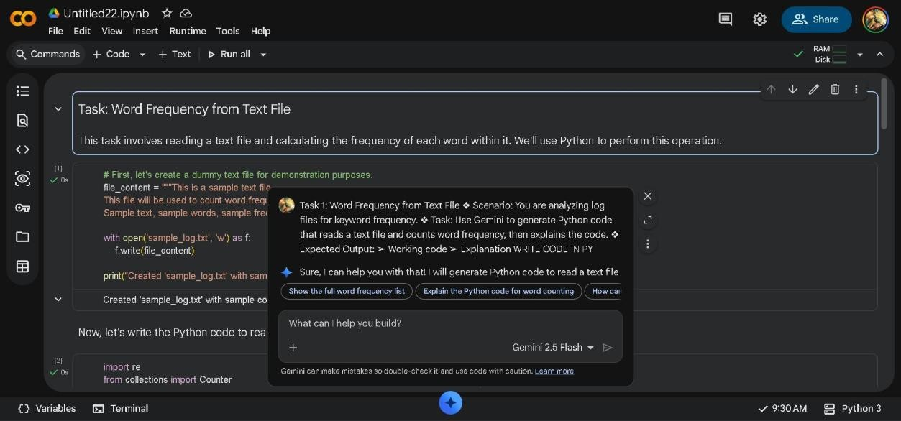
### Explanation of the Code:
- **Import necessary libraries:**
  - `re`: The regular expression module is used for robust word extraction
(splitting text into words while handling punctuation). `re.findall(r'\b\w+\b',
...)` finds all sequences of word characters. `\b` matches a word boundary, and `\w+` matches one or more alphanumeric characters (letters, numbers, and underscores).
  - `collections.Counter`: This is a specialized dictionary subclass for counting hashable objects. It's very efficient for frequency counting tasks.
- **`count_word_frequency(filepath)` function:** * Takes `filepath` as an argument.
  - Initializes an empty list `words` to store all extracted words.
  - Opens the specified file in read mode (`'r'`). The `with` statement ensures the file is properly closed even if errors occur.
  - Iterates through each `line` in the file.
  - For each line:
  - `line.lower()`: Converts the line to lowercase to ensure that words like "The" and "the" are counted as the same word.
  - `re.findall(r'\b\w+\b', ...)`: Uses a regular expression to find all words.
This effectively removes punctuation and splits the text into individual words.
  - `words.extend(...)`: Adds the list of words found in the current line to the overall `words` list.
  - Finally, `return Counter(words)` creates and returns a `Counter` object from the collected list of words, which automatically calculates their frequencies.
- **Execution Block:**
  - `file_path = 'sample_log.txt'`: Defines the name of the file to be analyzed.
  - `word_counts = count_word_frequency(file_path)`: Calls the function to get the word frequencies.
  - The code then prints the top 10 most common words and their counts
using `word_counts.most_common(10)`.
Task 2: File Operations Using Cursor AI ❖ Scenario:
You are automating basic file operations.
❖ Task:
Use Cursor AI to generate a program that:
- Creates a text file
- Writes sample text
- Reads and displays the content
❖ Expected Output:
➢ Functional code ➢
Cursor AI screenshots
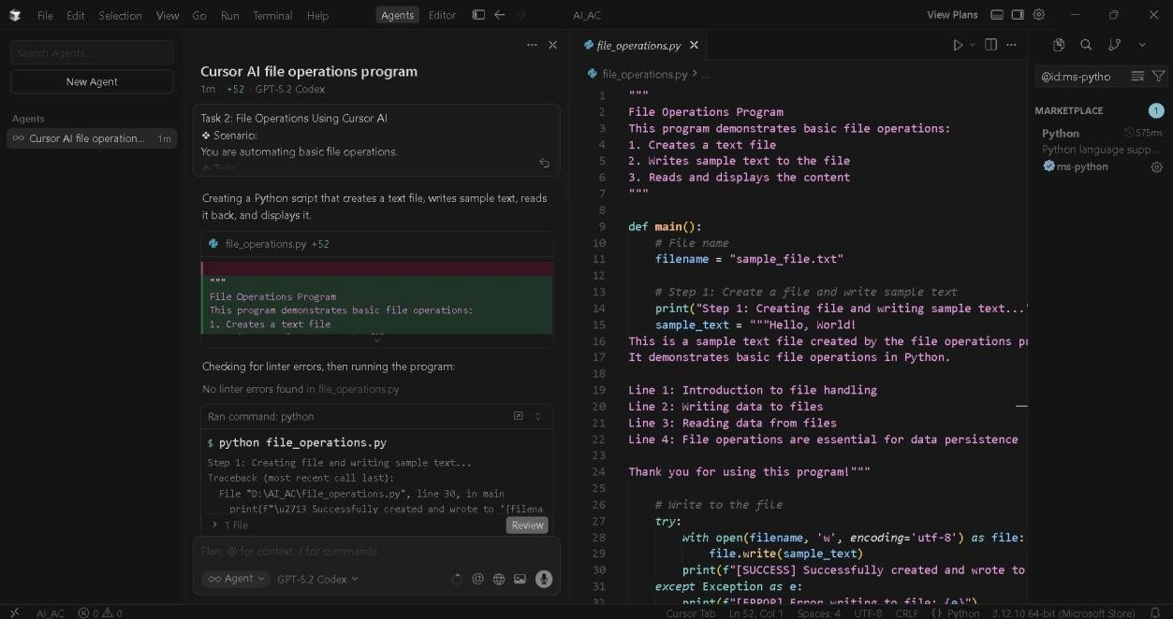
CODE:
"""
File Operations Program
This program demonstrates basic file operations:
- Creates a text file
- Writes sample text to the file 3. Reads and displays the content """
def main(): #
File name
filename = "sample_file.txt"
# Step 1: Create a file and write sample text print("Step 1: Creating file and writing sample text...") sample_text = """Hello, World!
This is a sample text file created by the file operations program.
It demonstrates basic file operations in Python.
Line 1: Introduction to file handling
Line 2: Writing data to files
Line 3: Reading data from files
Line 4: File operations are essential for data persistence
Thank you for using this program!"""
# Write to the file try:
with open(filename, 'w', encoding='utf-8') as file: file.write(sample_text) print(f"[SUCCESS] Successfully created and wrote to '{filename}'") except Exception as e:
print(f"[ERROR] Error writing to file: {e}")
return
# Step 2: Read and display the content print("\nStep 2: Reading and displaying file content...") try:
with open(filename, 'r', encoding='utf-8') as file: content = file.read()
print(f"\n--- Content of '{filename}' ---") print(content) print("--- End of file content ---") print(f"\n[SUCCESS] Successfully read '{filename}'") except FileNotFoundError: print(f"[ERROR] File
'{filename}' not found") except Exception as e:
print(f"[ERROR] Error reading file: {e}")
if __name__ == "__main__":
main()
OUTPUT:
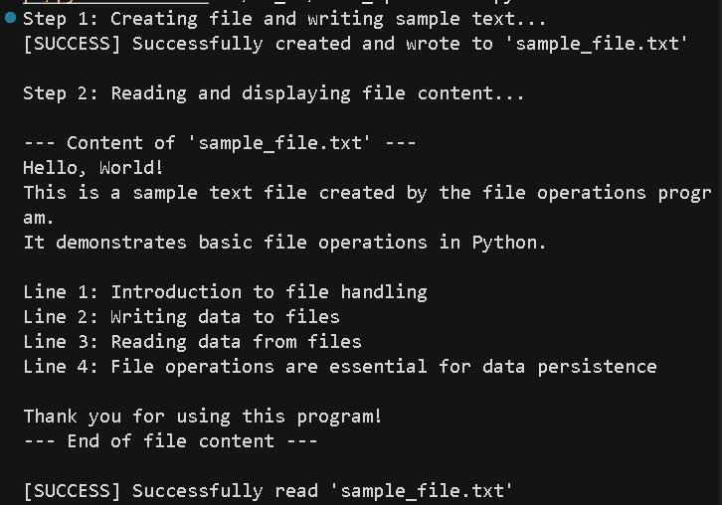
EXPLANATION:
Code Explanation: file_operations.py
Python script that demonstrates basic file operations. Here's what it does:
Overall Structure
The program performs two main tasks:
- Create and write to a text file
- Read and display the file's contents
Breakdown by Section
Lines 1-7: Documentation
  - Module-level docstring describing the program's purpose Lines 9-33: File Writing Section
Lines 11-24:
  - filename: Target file name ("sample_file.txt")
  - sample_text: Multi-line string containing sample content Lines 27-33: Write
Operation with open(filename, 'w', encoding='utf-8') as file: file.write(sample_text)
  - Uses a context manager (with) for automatic file handling
  - Mode 'w' opens for writing (creates or overwrites)
  - encoding='utf-8' ensures proper character handling
  - try/except: Handles errors (e.g., permission issues)
Lines 35-48: File Reading Section Lines 37-44: Read Operation with open(filename, 'r', encoding='utf-8') as file: content = file.read()
  - Mode 'r' opens for reading
  - file.read() reads the entire file into a string
  - Displays the content with formatting
Lines 45-48: Error Handling
  - FileNotFoundError: Handles missing file
  - Generic Exception: Handles other read errors Lines 50-51: Program Entry Point if __name__ == "__main__":
main()
  - Runs main() when executed directly
  - Allows importing as a module without running Key Concepts Demonstrated
- Context managers: Automatic file closing
- Error handling: Uses try/except blocks
- File modes: 'w' (write) and 'r' (read)
- UTF-8 encoding: Ensures international character support
This is a solid introduction to file I/O in Python with proper error handling.
Task 3: CSV Data Analysis
- Scenario:
You are processing structured data from a CSV file.
- Task:
Use Gemini in Colab to read a CSV file and calculate mean, min, and max.
- Expected Output:
- Correct output
- Screenshot
Load CSV Data Subtask:
Load the CSV file into a pandas DataFrame.

Reasoning: To load the CSV file into a pandas DataFrame and display its head, I need to import the pandas library and use its read_csv function, then call the head() method on the resulting DataFrame.
import pandas as pd df = pd.read_csv('data.csv') df.head() index,id,name,value OUTPUT:
0,1,Alpha,10.0
1,2,Beta,20.0
2,3,Gamma,15.0
3,4,Delta,25.0
4,5,Epsilon,12.0 **Reasoning**:
The previous attempt to load `data.csv` failed because the file was not found. To resolve this, I will create a dummy `data.csv` file with some sample data using a shell command, and then retry loading it into a pandas DataFrame.
OUTPUT:
%%writefile data.csv
id,name,value 1,Alpha,10
2,Beta,20
3,Gamma,15
4,Delta,25
5,Epsilon,12
import pandas as pd df = pd.read_csv('data.csv')
df.head()
Calculate Statistics Subtask:
Calculate the mean, minimum, and maximum for all numerical columns in the DataFrame.

Reasoning: To calculate the mean, minimum, and maximum for all numerical columns, I will use the .mean(), .min(), and .max() methods on the DataFrame df.
df_mean = df.select_dtypes(include='number').mean()
df_min = df.select_dtypes(include='number').min() df_max = df.select_dtypes(include='number').max()
print("Mean values:\n", df_mean)
print("\nMinimum values:\n", df_min) print("\nMaximum values:\n", df_max)
OUTPUT:
Mean values: value 16.4 dtype: float64 Minimum values: value 10.0 dtype: float64
Maximum values: value 25.0 dtype: float64
**Reasoning**:
The previous cell failed because the DataFrame `df` was not defined.
Although `data.csv` exists, the code to load it into `df` was not executed. Therefore, I need to include the necessary steps to load `df` from `data.csv` before calculating the statistics. import pandas as pd
df = pd.read_csv('data.csv')
df_mean = df.select_dtypes(include='number').mean()
df_min = df.select_dtypes(include='number').min() df_max = df.select_dtypes(include='number').max()
print("Mean values:\n", df_mean) print("\nMinimum values:\n", df_min) print("\nMaximum values:\n", df_max) OUTPUT:
Mean values: value 16.4 dtype: float64 Minimum values: value 10.0 dtype: float64
Maximum values: value 25.0 dtype: float64
Final Task Subtask:
Summarize the calculated statistics from the CSV file.
CODE EXPLANATOIN:
Certainly! The last code block you executed calculates and prints the mean, minimum, and maximum values for the numerical columns in your DataFrame df. Here's a breakdown:
- import pandas as pd: This line imports the pandas library, which is essential for working with DataFrames, and gives it the alias pd for convenience.
- df = pd.read_csv('data.csv'): This reads the data from your data.csv file and loads it into a pandas DataFrame named df.
- df_mean = df.select_dtypes(include='number').mean(): This selects all columns in df that have a numerical data type, and then calculates the mean for each of those numerical columns. The result is stored in df_mean.
- df_min = df.select_dtypes(include='number').min(): Similar to the mean, this selects numerical columns and calculates the minimum value for each, storing it in df_min.
- df_max = df.select_dtypes(include='number').max(): This selects numerical columns and calculates the maximum value for each, storing it in df_max.
- print(...): These lines then print out the calculated mean, minimum, and maximum values to the console, making them easy to view.
Task 4: Sorting Lists – Manual vs Built-in
- Scenario:
You are reviewing algorithm choices for efficiency.
- Task:
Use Gemini to generate:
- Bubble sort
- Python’s built-in sort() ➢ Compare both implementations.
❖ Expected Output:
- Two versions of code
- Short comparison
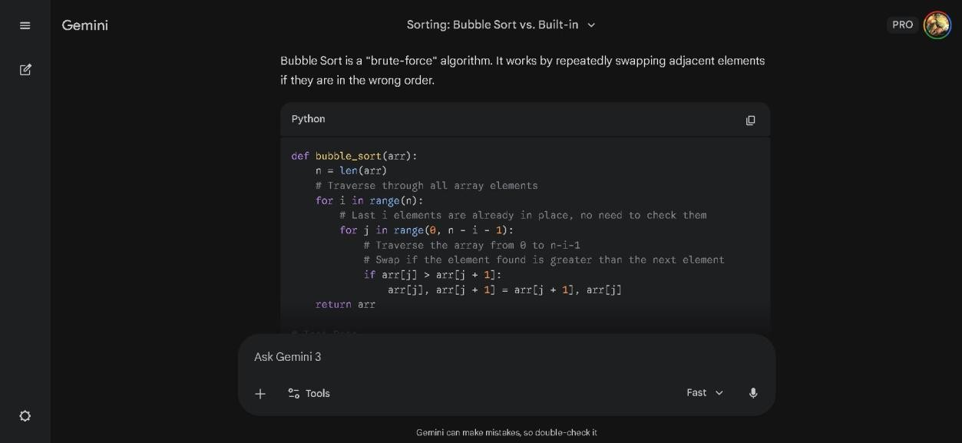
1. Manual Implementation: Bubble Sort
Bubble Sort is a "brute-force" algorithm. It works by repeatedly swapping adjacent elements if they are in the wrong order. Python def bubble_sort(arr):
n = len(arr)
# Traverse through all array elements for i in range(n):
# Last i elements are already in place, no need to check them for j in range(0, n - i - 1):
# Traverse the array from 0 to n-i-1
# Swap if the element found is greater than the next element if arr[j] > arr[j + 1]: arr[j], arr[j + 1] = arr[j + 1], arr[j]
return arr
# Test Data unsorted_list = [64, 34, 25,
12, 22, 11, 90] result = bubble_sort(unsorted_list) print(result)
Output:
Plaintext
[11, 12, 22, 25, 34, 64, 90]

2. Built-in Implementation: sort()
Python uses an algorithm called Timsort. It is a hybrid approach that is significantly faster and more memory-efficient than Bubble Sort.
Python #
Test Data
unsorted_list = [64, 34, 25, 12, 22, 11, 90]
# Use the built-in sort() method (modifies the list in place) unsorted_list.sort()
print(unsorted_list) Output:
Plaintext
[11, 12, 22, 25, 34, 64, 90]

- Comparison Summary
Feature | Bubble Sort | Python sort()
Complex | $O(n^2)$ (Slow | $O(n \log n)$ (Fast)
Effort | Manual logic re | Optimized built-in function

Feature | Bubble Sort | Python sort()
Usage | Educational / T | h Real-world applications

- Code Explanation
Bubble Sort Explanation:
- Nested Loops: The outer loop (i) keeps track of how many passes we have made. The inner loop (j) compares side-by-side numbers.
- The "Bubble" Mechanism: In every pass, the largest unsorted number "bubbles up" to its correct position at the far right of the list.
- Efficiency Issue: Because it uses nested loops, if you double the number of items in a list, the time it takes to sort them quadruples.
Built-in sort() Explanation:
- Timsort Logic: Instead of just swapping, it identifies small segments of the data that are already sorted (called "runs") and merges them efficiently.
- Optimization: It is written in C, making it hundreds of times faster than a manual Python loop for large datasets.
- In-place Mutation: The .sort() method changes the original list directly, which is highly memory-efficient.
Would you like me to demonstrate how to use sorted() instead, if you want to keep your original list unchanged?

